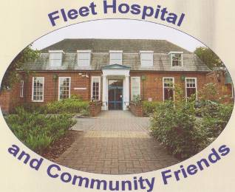

FLEET HOSPITAL AND COMMUNITY FRIENDS Charity No 1109526
“Supporting local Health Care needs
November 2019 Christmas Newsletter.
This Photo by Unknown Author is licensed under CC BY-NC

Dear Friend,
“I’m sure it’s only three months since I was typing last year’s Christmas newsletter”
It has been a rather frustrating year for the plans for the hospital. As I told you in the April newsletter there were plans for a 1.5 million revamp of the building and services at the hospital. Work was due to start in August 2018, but planning permission has been a problem. We all have our fingers crossed that the project goes ahead, as it will safeguard the future of the site.
Our membership has increased to 110, which is not a real reflection ,as some members represent bigger groups within Fleet. We still need younger members to come onboard to replace the older generation.
I hopefully will be stepping down as membership secretary, as my role as Vice Chair has developed over the passed few years. I will let you know the new person as soon as I can strong arm them into post.
Just to remind you all that you can pay your subs directly into the banks. I can give you details of our account.
Thank you all for your continued support to the Friends. We have recently supported several initiatives.
£42,000 for a Urology Scanner for OPD.
£3,000 toward the setup of an “Man with a Van” project. This enables the Occupational Therapists to visit resident’s homes to support them when in crisis. This will prevent unnecessary admissions to A&E, and calls to the emergency services. The van will have all the equipment needed when people fall or need increased emergency support.
We have also donated to the Samaritans.
There have also been other smaller spends.
Dates for your Diary
November 30th Christmas Fair 10am-12md, at all Saint church. We do need more tombola items.
December 18th at 6.30pm the Carol services on Calthorpe Ward
February 28th at All Saints. Let me know if you want to bring a team, £12 a head with supper.
We would love to meet our members if you can pop down to the Fair.
Best wishes for a Happy Christmas.
Harrie Glossop. Telephone No. 07810731958

